How to Inactivate Students

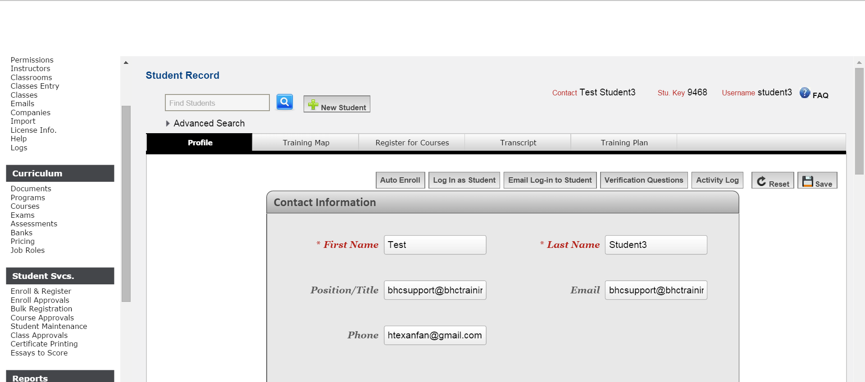
- Go to “ENROLL & REGISTER” in the menu under Student Svcs.
- In the Search window look up your student

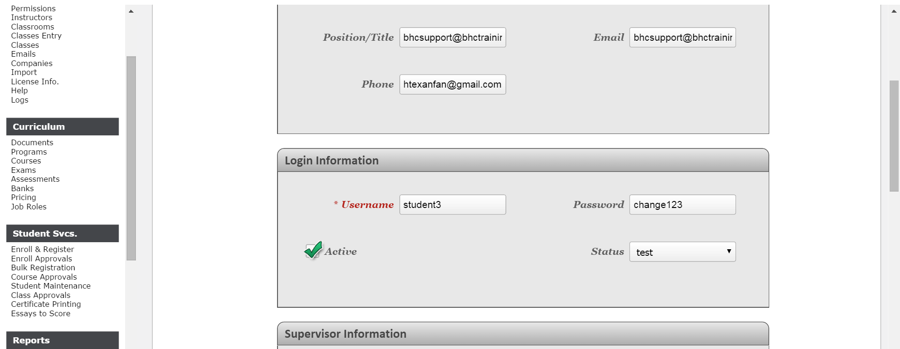
- Under LOGIN INFORMATION on the students Demographic
  - UNCHECK the ACTIVE
  - Change “STATUS” to “UNKNOWN” (not closed)
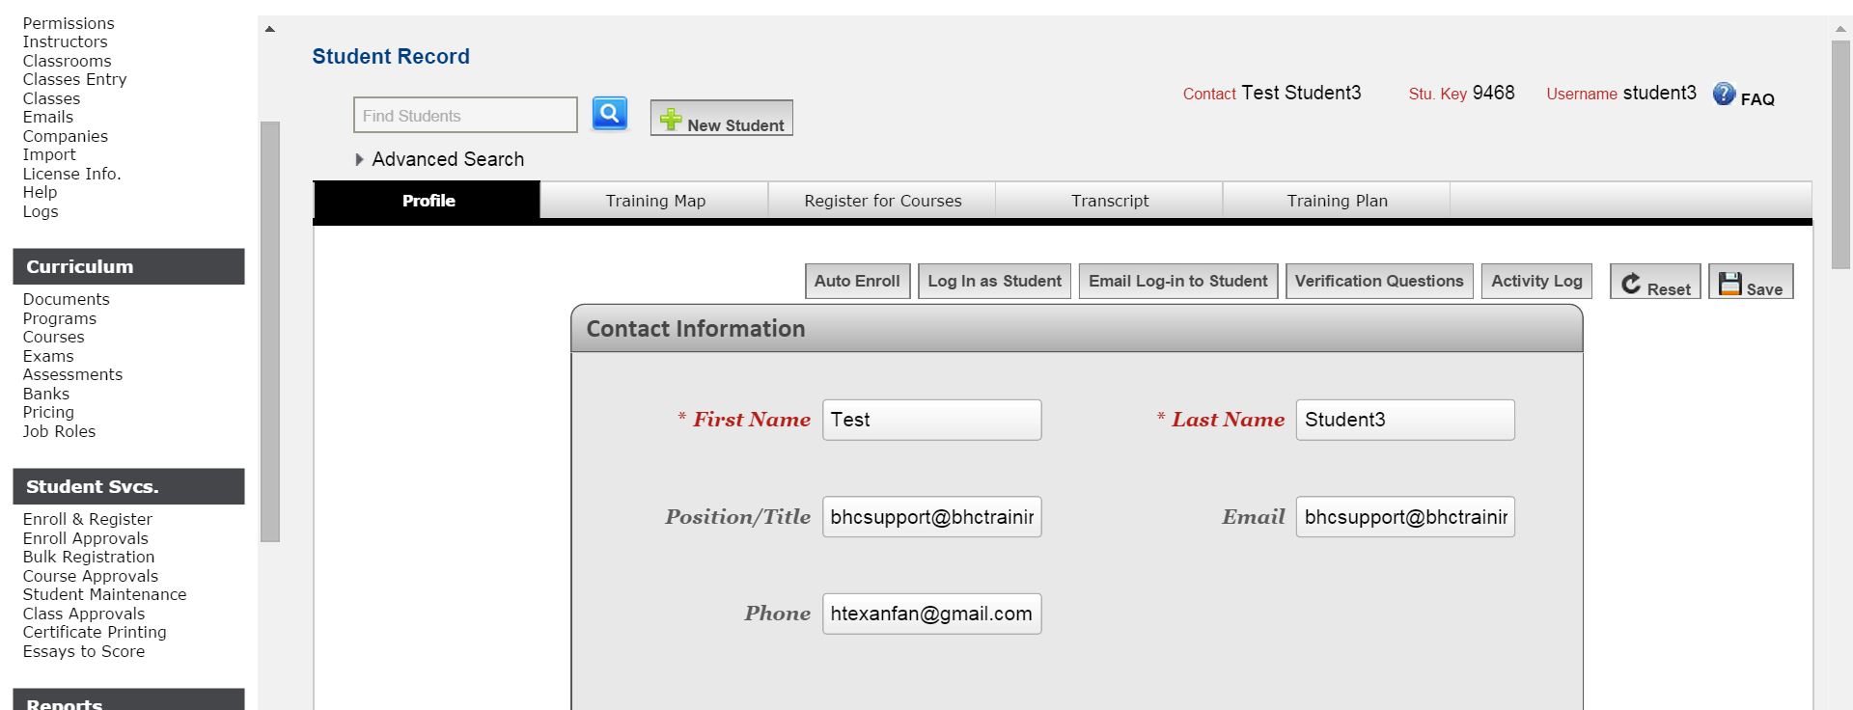
- HIT SAVE

